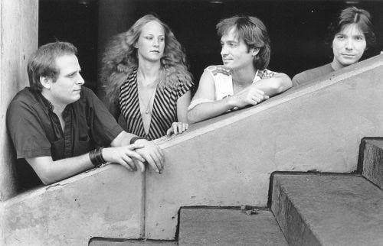

FOR IMMEDIATE RELEASE:
ART IN AMERICA RETURNS WITH ‘CLOUDBORN’
One of the most original sounding rock bands of the '80s, Art in America, is back with a powerful new album 'Cloudborn.' This long-awaited follow-up to their acclaimed debut, 'Art in America,' can now be purchased as a collector's edition digipak via the following link: https://store.cdbaby.com/cd/artinamerica12
Featuring several instruments that remain quite uncommon in a rock context (including a concert harp, Indian tambura and Japanese koto), the group - comprised of Chris Flynn: guitar, lead vocals; Shishonee Flynn: concert harp, koto, tambura, vocals; Dan Flynn: drums, percussion; and Jim Kuha: bass guitar, 12 string, bass pedals, vocals - toured with the likes of U2, King Crimson, and Roxy Music. Additionally, their video for the song “Art in America” was aired by the then-fledgling MTV. Their instantly classic album cover was designed by renowned rock artist Ioannis, and was celebrated in Michael Ochs book ‘1000 Record Covers,’ while the album was produced by renowned prog producer Eddy Offord, and featured a guest appearance by Dixie Dregs/Kansas/Deep Purple guitarist Steve Morse.
‘Cloudborn’ (which also features new artwork once again from Ioannis) follows years of anticipation from fans for more music from the Detroit-based band that blazed new trails in the American progressive rock scene. It picks up seamlessly where the debut album left off, as evidenced by such standout selections as “Someday” and “I am I,” as heard in these lyric videos:

https://www.youtube.com/watch?v=hmnlXq9OBDY
https://www.youtube.com/watch?v=CWHUTSIFQ-Y
A compilation of songs from three decades, the listener's travels begin with “A Tale of the Unexpected”, an opening blend of current news clips all accented with the sweeping chords of an original Mellotron. Chris Flynn reminisces about the early years of innocence and the joy of childhood in Ohio in an eight minute masterpiece “When We Were Young.” The piece opens and concludes with two sections borrowed from two George Butterworth classical music works “A Shropshire Lad” and “The Banks of Green Willow.” The album ends with the powerful arena rock trilogy “Goodbye My Love,” “Mind's Eye” and “Peace of Mind.” Further info for each song can be viewed here: https://www.artinamericamusic.com/cloudborn-notes.html
Production credits go to producer extraordinaire David Hentschel (Genesis, Elton John, Queen and George Harrison), bassist Jim Kuha (four songs) and Chris Flynn (four songs). The opening six songs feature guest artist and bassist Tony Levin. A piano solo by David Hentschel in the aforementioned song “Someday” is a noted treat. Prog lovers everywhere will appreciate the intricate progressive landscapes, as well as the lovely ballads from guitarist Chris Flynn.
"This album takes you on a journey into melodic, progressive, art rock serving up a sampling of our band's past and present musical adventures. We hope you enjoy it!" - Shishonee Flynn
‘CLOUDBORN’ TRACKLIST:

1. A Tale of the Unexpected
2. I Am I
3. Someday
4. Drool
5. The New Swami
6. Someone Called My Name
7. For Shelly
8. When We Were Young
9. Facelift
10. Don't Look Down
11. No Wonder
12. Goodbye My Love - The Mind's Eye - Peace of Mind

FOR MORE INFORMATION, PLEASE VISIT: artinamericamusic.com

FOR FURTHER INFORMATION ON ART IN AMERICA, PLEASE CONTACT:
Chip Ruggieri
Chipster P.R & Consulting Inc.
chip@chipsterpr.com

