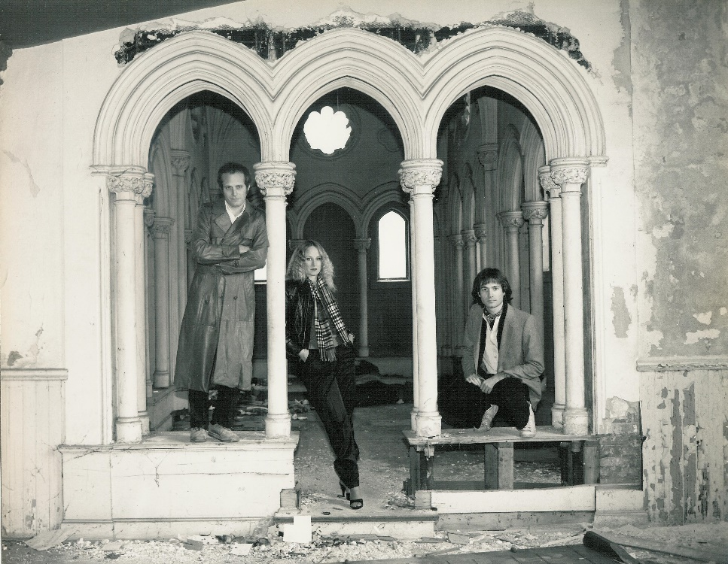

Art in America - Bio
It all began in our living room when family members Chris, Dan, and Shishonee Flynn were kicking around some musical ideas with guitar, bass, drums and some unusual instrumentation - a concert harp, Indian tambura and Japanese koto. Soon we added bass player Jim Kuha and hit the road. After paying our dues on the bar circuit, our music evolved, forged in the fire of the explosive 70’s and 80’s Detroit rock scene. Our songs were an unusual blend of classical, symphonic hard rock but with a twist – Art in America was the first rock band to feature a concert harp. As interest grew, we attracted offers from A&R (record label) scouts, landing a record deal with Sony/Pavilion records. Our first album, Art in America, was produced by rock legend Eddie Offord (Yes) and we toured opening up for such bands as U2, King Crimson, Bill Bruford, and Roxy Music. Eventually, after performing extensively, “life happened” - band members married and raised families, while continuing to write and stream AIA music online. In 2013, we connected with producer David Hentschel (Genesis, Elton John) and released our second album, The Hentschel Sessions. In 2019, we followed this up with Cloudborn which includes songs from the Hentschel project, four songs produced by Chris Flynn, and four songs produced by Jim Kuha from a special release of a rare 1984 AIA recording. Visit our website to learn more about our journey: www.artinamericamusic.com

The Lineup:
Chris Flynn – guitar, lead vocals
Shishonee Flynn – concert harp, koto, tamboura, vocals
Dan Flynn – drums, percussion
Jim Kuha – bass guitar, 12 string, bass pedals, vocals
Garry Galloway – keyboards

