ART IN AMERICA RELEASES NEW ALBUM CLOUDBORN

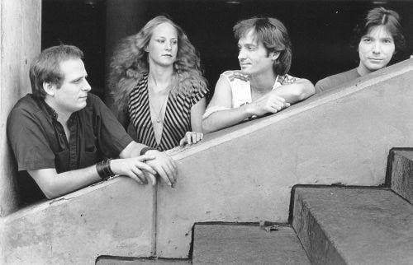

Los Angeles, CA – Critically acclaimed Detroit art rock band Art in America announces the release of Cloudborn, the long awaited follow-up to its groundbreaking self-titled first album, Art in America. Cloudborn follows years of anticipation and requests from fans for more music from a band that blazed new trails in the American progressive rock scene. Art in America was the first band to feature a concert harp as the main instrument in a rock band. Cloudborn takes full advantage of the Lyon and Healy harp as well as introducing Indian tambura and Japanese koto into the new album.

No conversations about 1980’s progressive rock would be complete without the mention of Art in America. Their first album, Art in America was produced by progressive rock legend Eddy Offord, whose work with iconic bands like Yes and Emerson, Lake and Palmer made him the only natural choice for producer. AllMusic reviewer Gina Boldman summed up their debut album as “a pleasing mix of harp, guitar and keyboards, a pretty and slightly mystic album with hints of album rock and pop…” The video for the album’s title track was featured heavily on MTV and the band toured with such bands as U2, King Crimson, and Roxy Music. Art in America’s instantly classic album cover was designed by renowned rock artist Ioannis and was celebrated in Michael Ochs book “1000 Record Covers.” The band continues that tradition by having Ioannis design the cover for their latest album Cloudborn.

Cloudborn picks up seamlessly where the debut album left off. A combination of songs from three decades, the listener's travels begin with “A Tale of the Unexpected”, an opening blend of current news clips all accented with the sweeping chords of an original Mellotron. Chris Flynn reminisces about the early years of innocence and the joy of childhood in Ohio in an eight minute masterpiece “When We Were Young.” The piece opens and concludes with two sections borrowed from two George Butterworth classical music works “A Shropshire Lad” and “The Banks Green Willow.” The album ends with the powerful arena rock trilogy “Goodbye My Love”, “Mind's Eye” and “Peace of Mind.”

Production credits go to producer extraordinaire David Hentschel (Genesis, Elton John, Queen and George Harrison), bassist Jim Kuha (four songs) and Chris Flynn (four songs). The opening six songs feature guest artist and bassist Tony Levin. A piano solo by David Hentschel in the song “Someday” is a noted treat. Prog lovers everywhere will appreciate the intricate progressive landscapes, as well as the lovely ballads from guitarist Chris Flynn. All progressive rock enthusiasts are encouraged to make this album a part of their collection.

CONTACT US at our website: www.artinamericamusic.com
Email Chris Flynn crootnik@gmail.com

